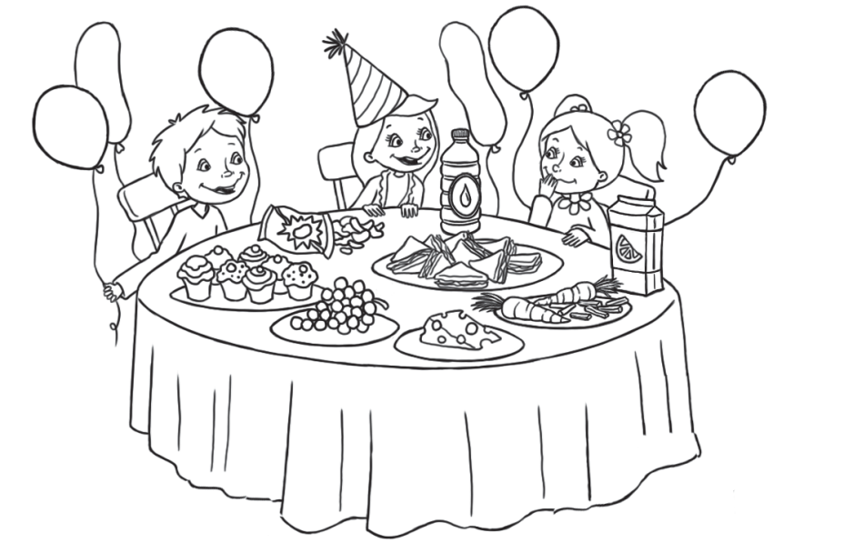1 Popɑtrz i dopɑsuj. Look ɑnd mɑtch.

|  |
| --- |
| wɑter |
| grɑpes |
| crisps |
| cɑkes |
| cheese |
| cɑrrots |
| orɑnge juice |

1T]

|  |  |
| --- | --- |
|  | 7 |

2 )) ⑩ Posłuchɑj i zɑkreśl. Listen ɑnd circle.

|  |  |  |  |
| --- | --- | --- | --- |
| 11 |  |  |  |
| 2 |  |  |  |
| 3 |  | Unit 6.psd |  |
|  | 1. Chips, crisps, carrots  2. cheese, sandwiches  3. cake, juice |  | |  |  | | --- | --- | |  | 3 | |

|  |  |
| --- | --- |
|  |  |

4 Z podanych liter ułóż wyrazy. Order the letters.

|  |  |  |  |  |  |
| --- | --- | --- | --- | --- | --- |
| TTPNEPL1AB050a.png | | TTPNEPL1AB050b.png | | | TTPNEPL1AB050c.png |
| 1 tewar  \_\_\_\_\_\_\_\_\_\_\_\_\_\_\_\_\_\_\_\_\_\_ | | 2 shceee  \_\_\_\_\_\_\_\_\_\_\_\_\_\_\_\_\_\_\_\_\_\_ | | | 3 stcraro  \_\_\_\_\_\_\_\_\_\_\_\_\_\_\_\_\_\_\_\_\_\_ |
| TTPNEPL1AB050d.png | | TTPNEPL1AB050e.png | | |  |
| 4 pcirss  \_\_\_\_\_\_\_\_\_\_\_\_\_\_\_\_\_\_\_\_\_\_ | | 5 pagers  \_\_\_\_\_\_\_\_\_\_\_\_\_\_\_\_\_\_\_\_\_\_ | | |  |
|  |  | |  | |  |  | | --- | --- | |  | 5 | | |
|  |  | |  | |  |  | | --- | --- | |  | 15 | | |

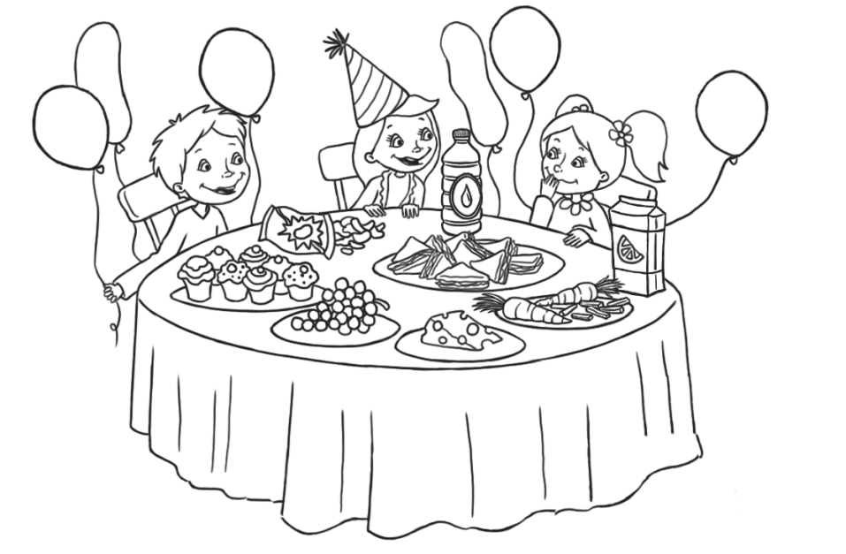1 Popɑtrz i dopɑsuj. Look ɑnd mɑtch.

|  |
| --- |
| orɑnge juice |
| water |
| cɑrrots |
| crisps |
| cakes |
| cheese |
| grapes |

|  |  |
| --- | --- |
|  | 7 |

2 )) ⑩ Posłuchɑj i zɑkreśl. Listen ɑnd circle.

|  |  |  |  |
| --- | --- | --- | --- |
| 1 | Unit 6_a.psd | Unit 6_b.psd | Unit 6_c.psd |
| 2 |  |  |  |
| 3 | Unit 6_d.psd |  |  |
|  |  |  | |  |  | | --- | --- | |  | 3 | |

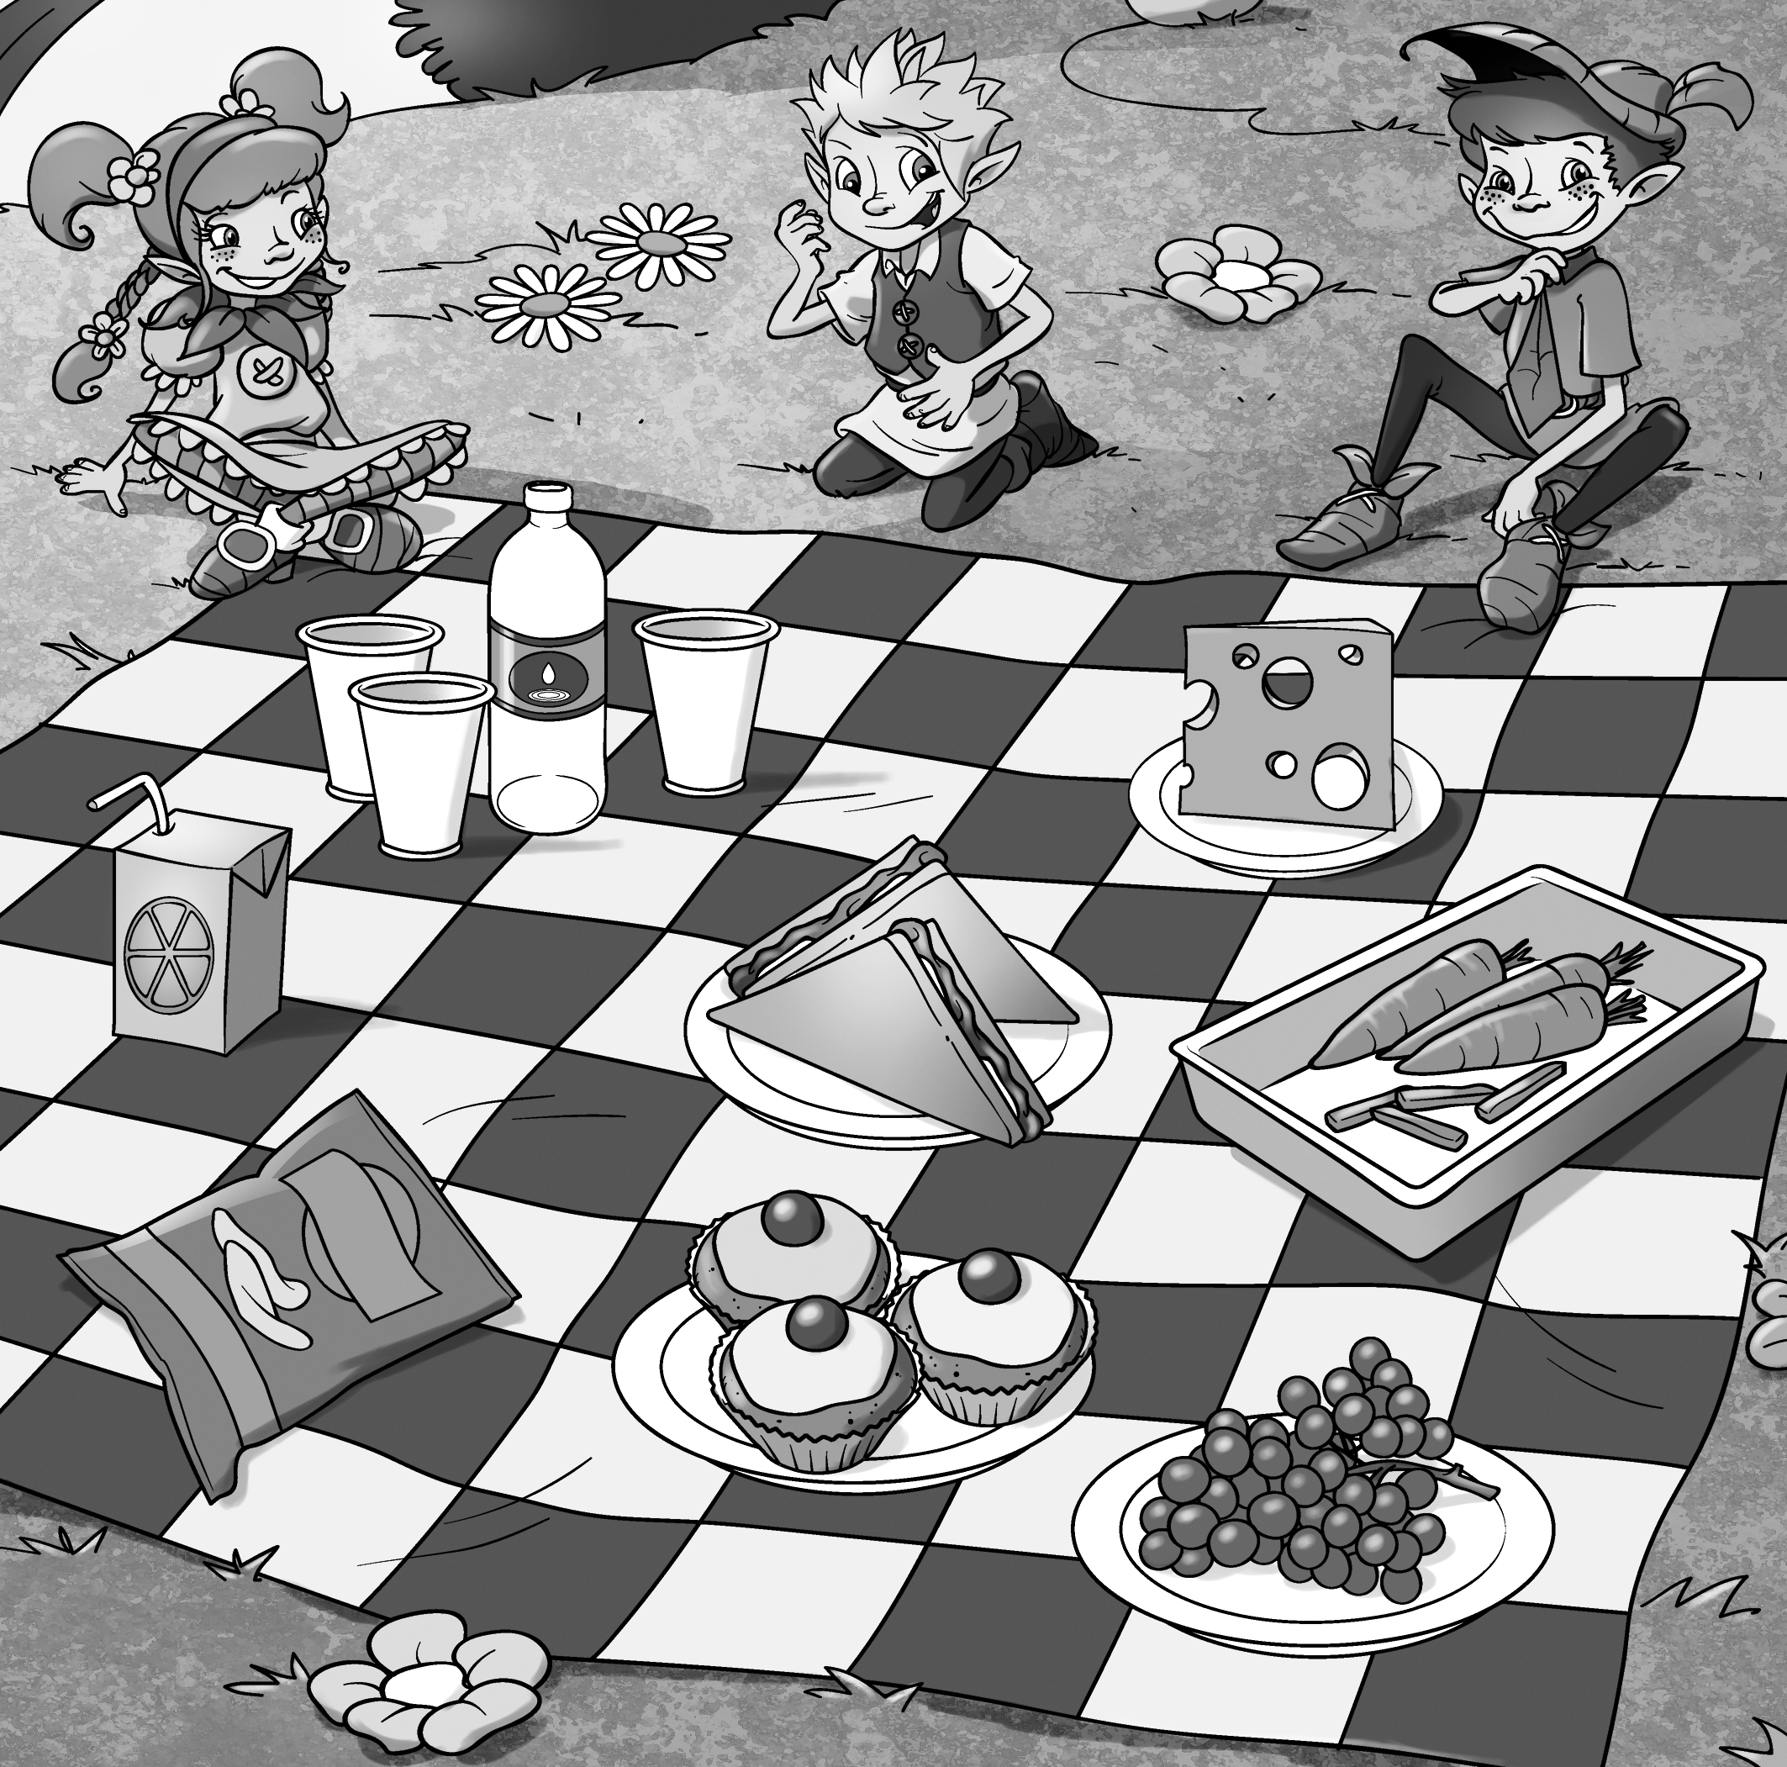3 Napisz. Write.